# Assignment 3: Make your first recording

## Open WorkFusion Studio.

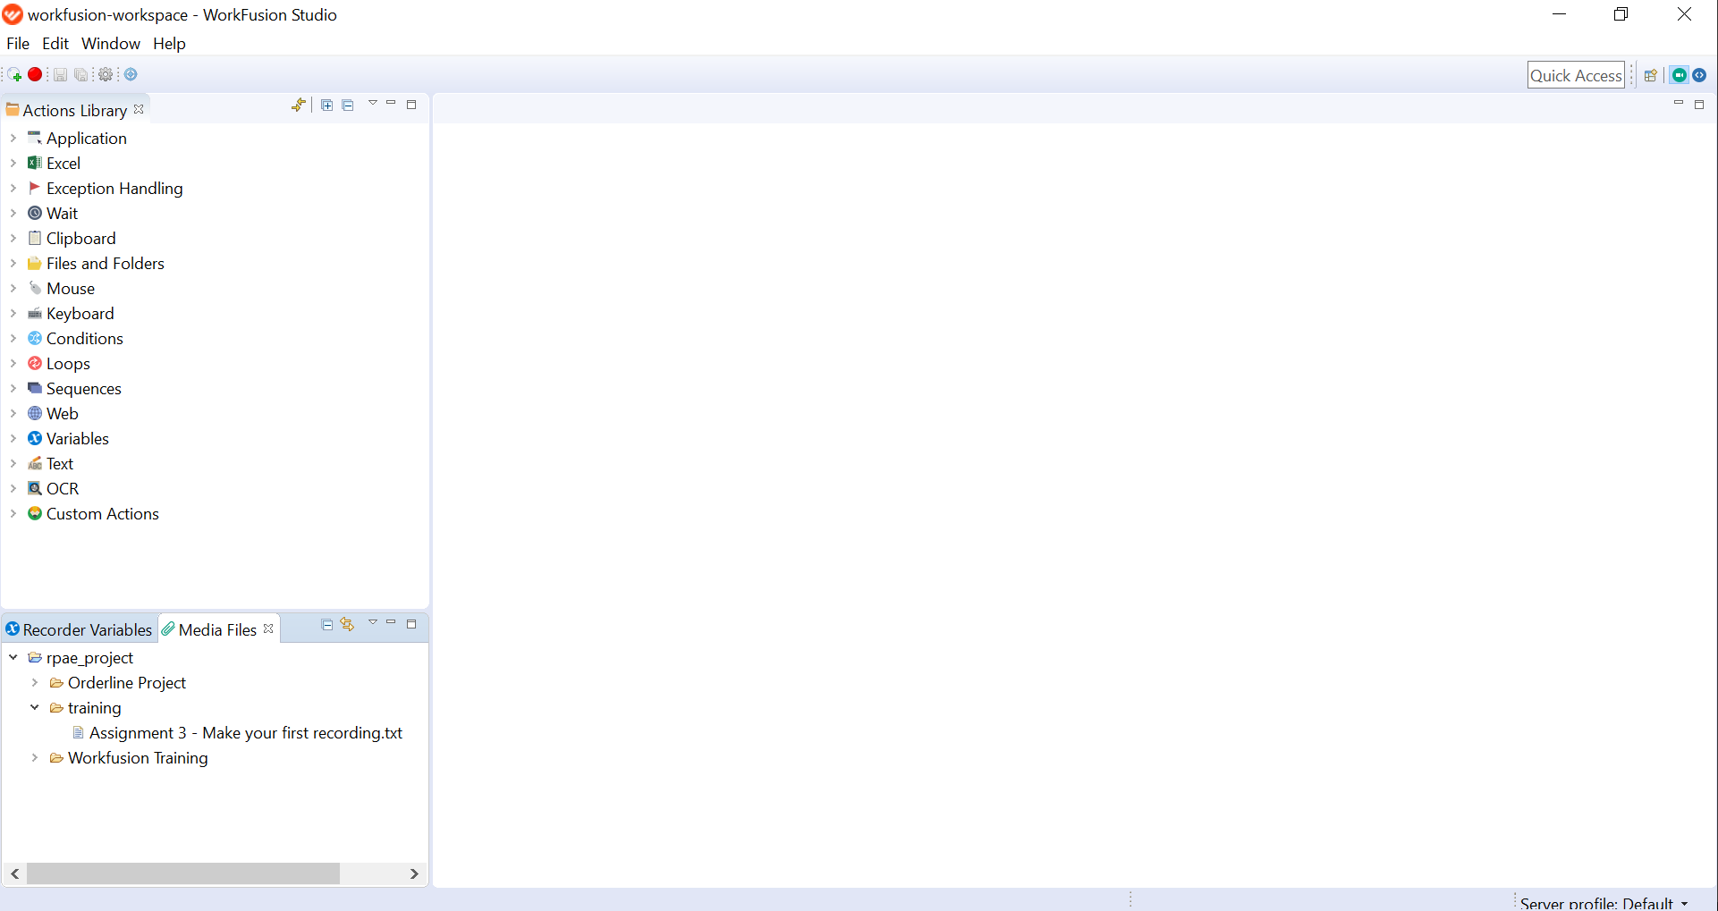

## Click Create new recording.

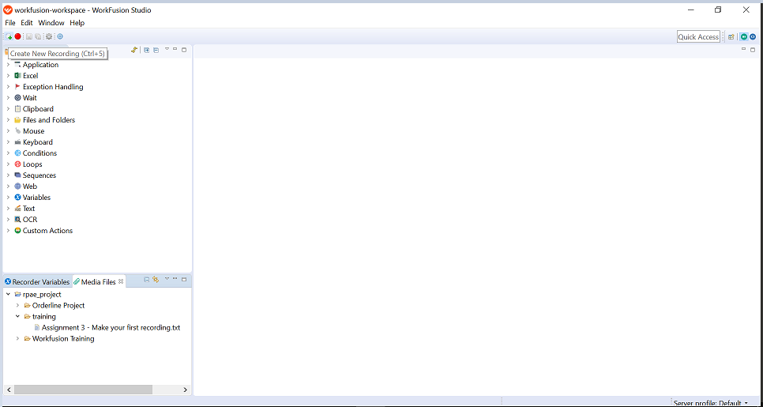

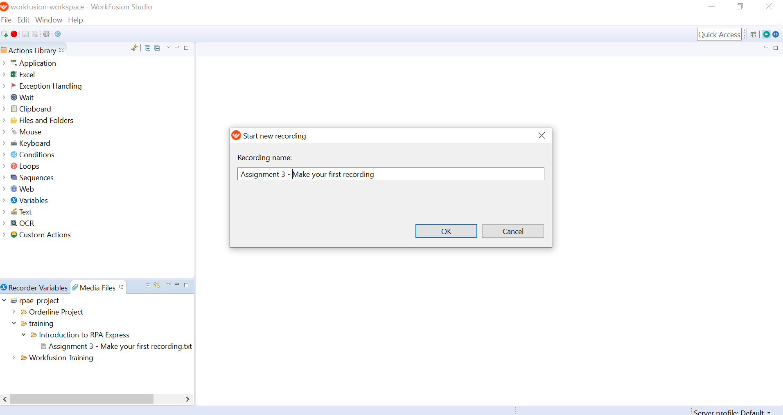

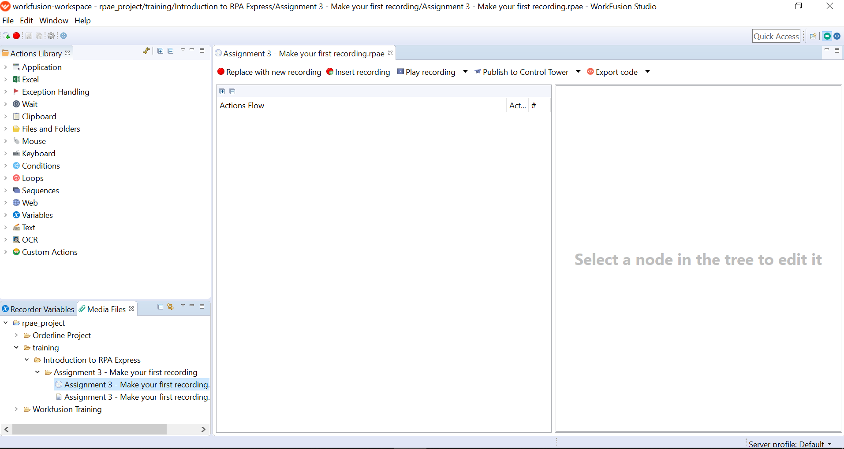

## Click Insert Recording.

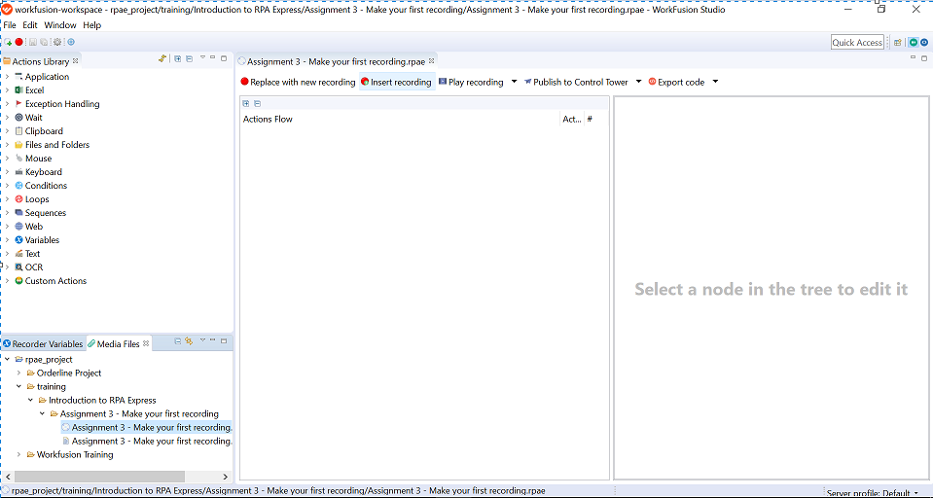

## Record the following actions:

## Open Calculator

## Make some calculations with buttons

## Close the application

## Stop recording.

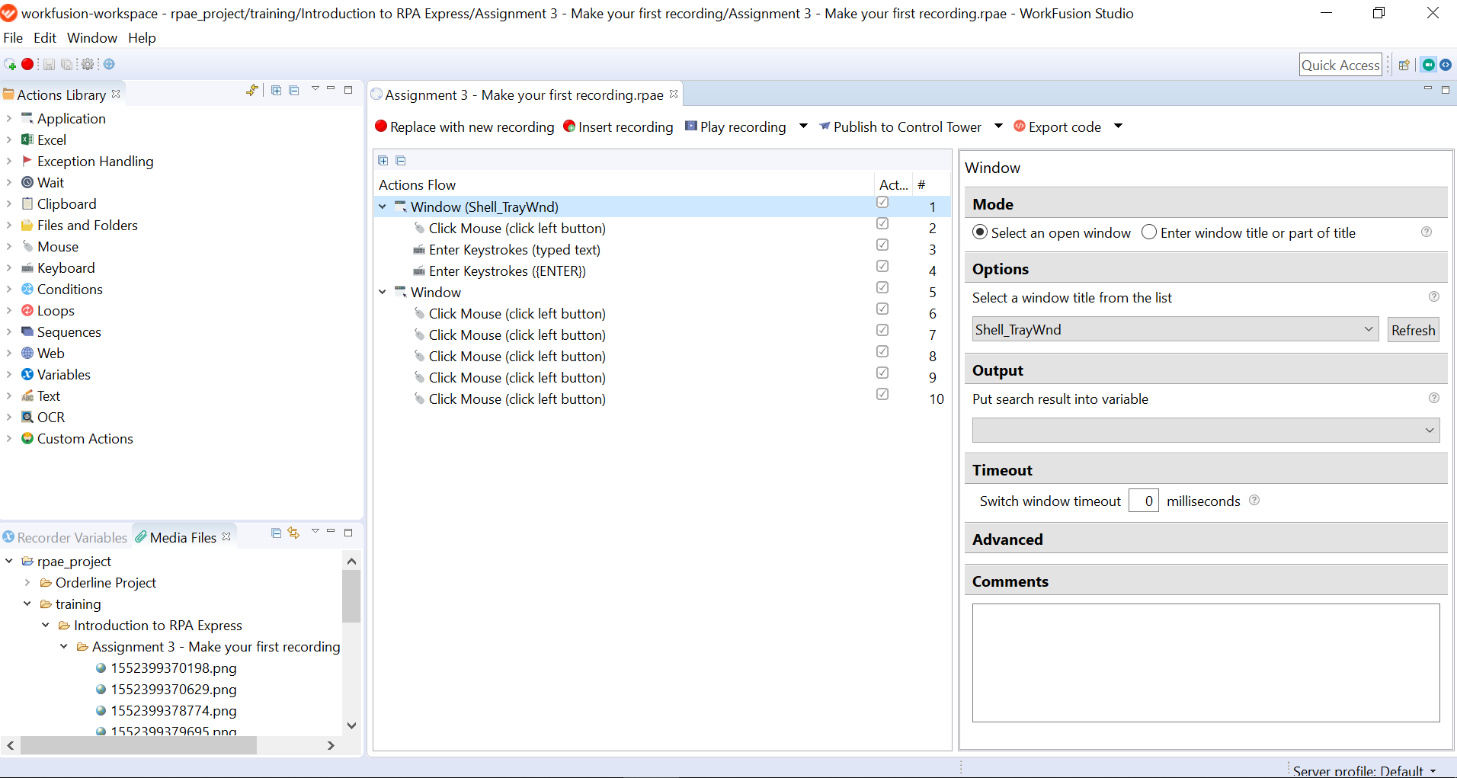

## See what action were recorded.

## Try to Play recording.

Link of the recording